**TOLLCROSS COMMUNITY COUNCIL**

31 December 2024

Head of Planning

Department of City Development

City Development – Planning & Strategy

Waverley Court

4 East Market Street

Edinburgh EH8 8BG

**Change of Use from retail (Class 1A) to cafe (Class 3) and hot food takeaway (Sui Generis) at 29 Home Street, EH3 9JR**

**24/06189/FUL**

**Case Officer : Local1 Team planning.local1@edinburgh.gov.uk**

Tollcross Community Council would like to object to this application on the grounds that it contravenes the new LDP, Guidance for Business (2024) and Supplementary Guidance for Tollcross Town Centre (Dec. 2017).

The proposed premises has been, until recently, a retail outlet for many years. The proposal is essentially for a take-away; to quote the applicants Planning Statement; *‘‘While the majority of our offerings will be designed for takeaway, we will also provide limited seating for on-premises consumption, ensuring flexibility and convenience for our patrons.’’*

1. **Rationale**

The community council has tried to stem the constant loss of class 1 uses, that support local residents, with their replacement by facilities clearly aimed at short term visitors. In this case, the proposal is within a retail frontage where planning guidance states this change will not be permitted. Just one example of how this affects residents is the situation in central Amsterdam. Local residents say they are being forced out of the central area as there are now no outlets for their needs but only outlets to support tourists. Cities around the world are taking action to stem this process.

1. **Supplementary Guidance – Tollcross Town Centre (December 2017)**

The supplementary Guidance states the following:

TC1

The change of use of a shop unit to a non-shop use will not be permitted, (with the exception of the corner units where Class 3 Food and Drink uses are considered appropriate) on the following frontages:

• 120–148 Lothian Road

• 2-48 Earl Grey Street

• 1-65 Home Street

The proposal is at 29 Home Street which is within the frontages where this would not be allowed.

1. **The Local Development Plan**

**Re 11 Food and Drink Establishments**

*The change of use of a shop unit or other premises to a licensed or unlicensed restaurant, cafe, pub, or shop selling hot food for consumption of the premises (hot food take-away) will not be permitted: a. if likely to lead to an unacceptable increase in noise, disturbance, on-street activity or anti-social behaviour to the detriment of the living conditions or health and wellbeing of nearby residents,*

***or b. in an area where there is considered to be an excessive concentration of such uses to the detriment of the living conditions or health and wellbeing of nearby residents.***

1. **The Local Development Plan**

**Re 4 Alternative Use of Shop Units in the City Centre and Town Centres**

***In the City Centre Retail Core and town centres, change of use proposals which would undermine the retailing function of the centre will not be permitted.*** *Detailed criteria for assessing proposals for the change of use of a shop unit to a non-shop use will be set out in supplementary guidance* (see 2. Above)*. Supplementary Guidance* *will detail an approach tailored to different parts of the city centre retail core and each town centre to be informed by town centre health checks which will assess the centres strengths, vitality and viability, weaknesses and resiliencies.*

1. **Guidance for Business (2024)**

Restaurants, cafés, snack bars and other Class 3 Uses: Proposals in predominantly housing areas will not normally be permitted.

Page 10 shows that this is in an area of restriction due to an over-concentration of food outlets

The map identifies areas of restriction. *‘’These are areas of mixed but essentially residential character where there is a high concentration of hot food takeaways, public houses and entertainment venues’’*.

The map shown below demonstrates that the application is in this restricted area.

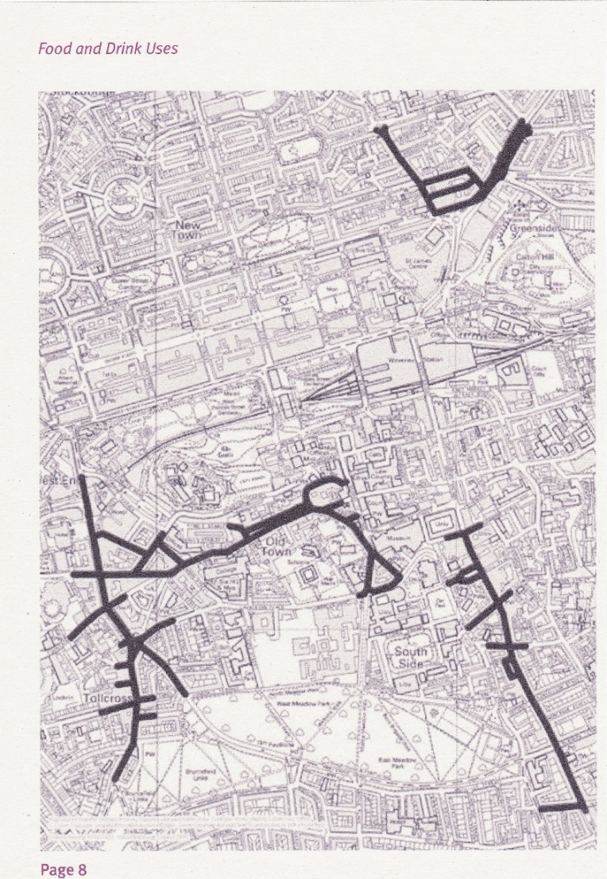

It is for these reasons of non-compliance with planning rules and guidance that we ask that this application should be refused.

Yours sincerely, Tollcross Community Council